Go to the **VCSS website** → [**https://vcss.ocfo.gsa.gov/Default.aspx**](https://vcss.ocfo.gsa.gov/Default.aspx)

Click on “**Support Request**” button.

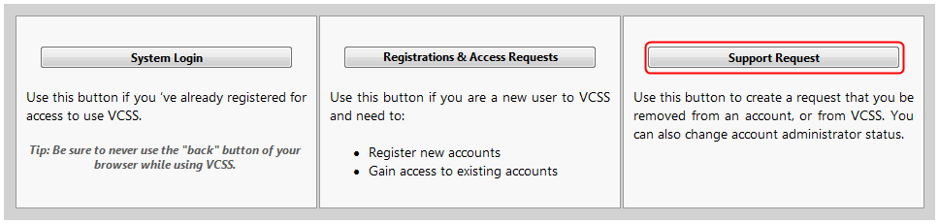

Select “**Update User Profile**” under the “**Topic**” drop-down menu.

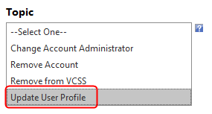

Select “**Vendor**” or “**Customer**” in answer to “**I am a:**” and fill out the form with the current and updated information.

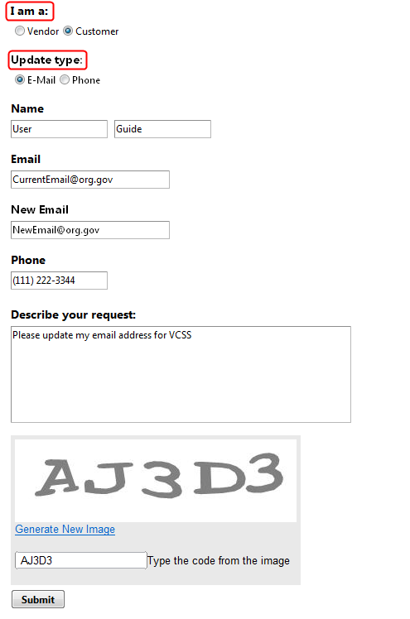

When you have successfully requested to have your contact information updated you will receive a “Thank-you note” on the website as well as an email. If you do not receive change notification within two business days, please forward the email to [businessapps@gsa.gov](mailto:businessapps@gsa.gov) so that a status update can be provided.

